**Docker-Compose-Practice-Experiment**

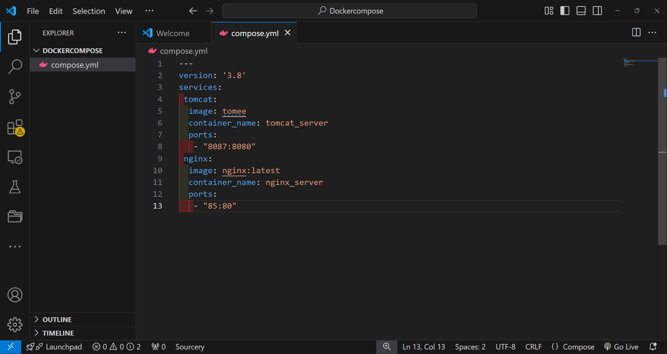

Create a Folder Go to your desktop or any folder you prefer.

Now open any text editor and create a .yml file in the folder and paste the yaml configuration for tomcat and nginx

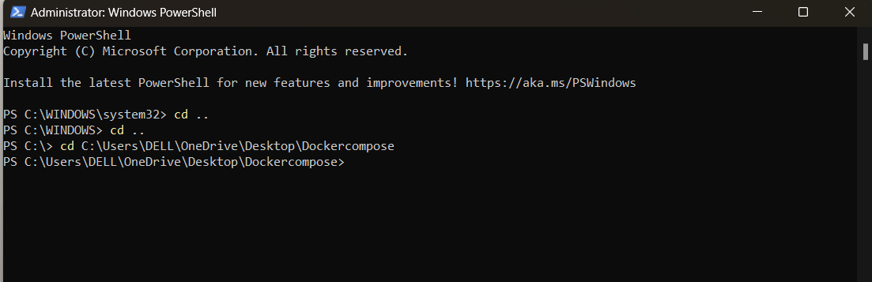

Now open windows powershell as administrator and navigate to the created folder

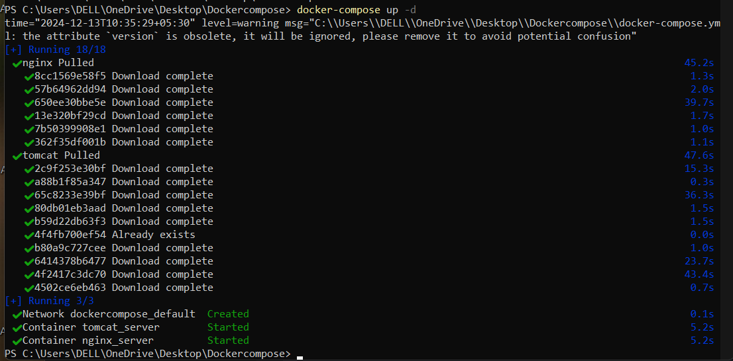

Start the Containers

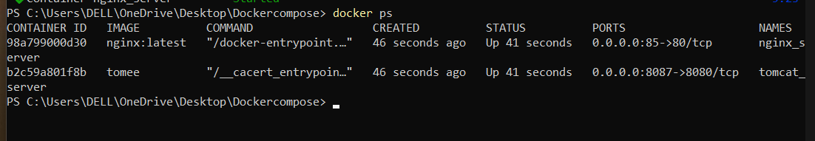

Display all running containers

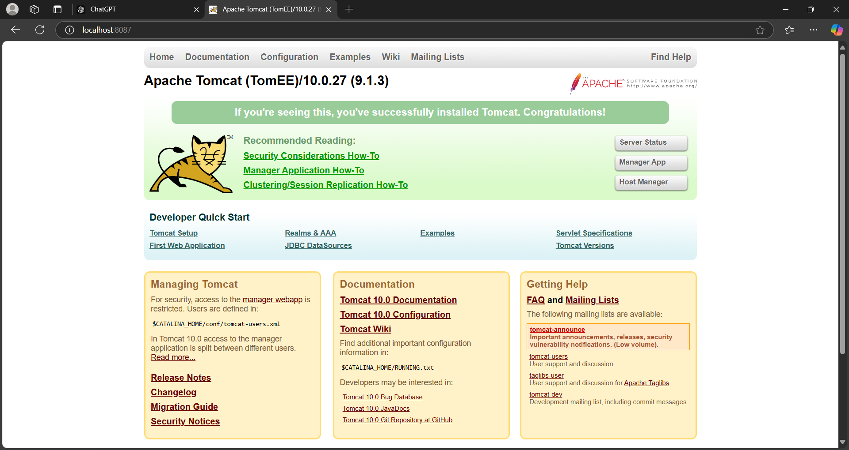

Access the Applications Locally localhost:8087

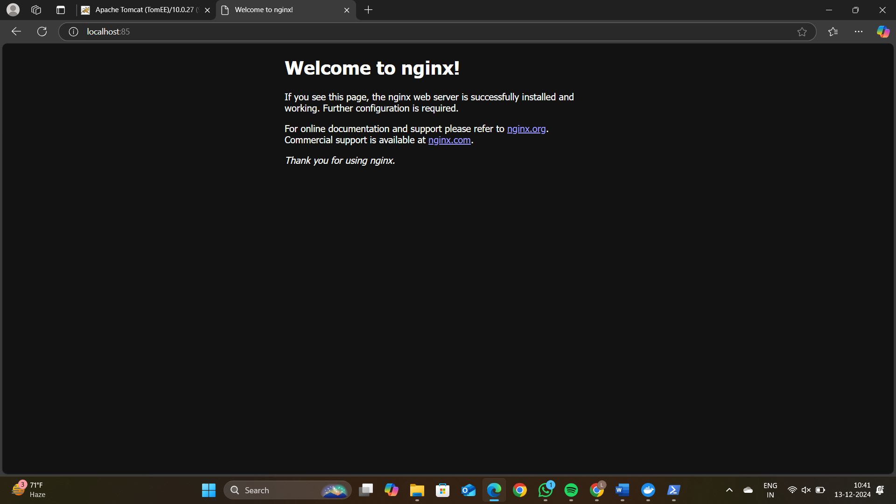

Access the Applications Locally localhost:85

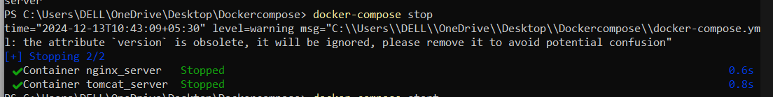

Now next step To stop the containers without removing them

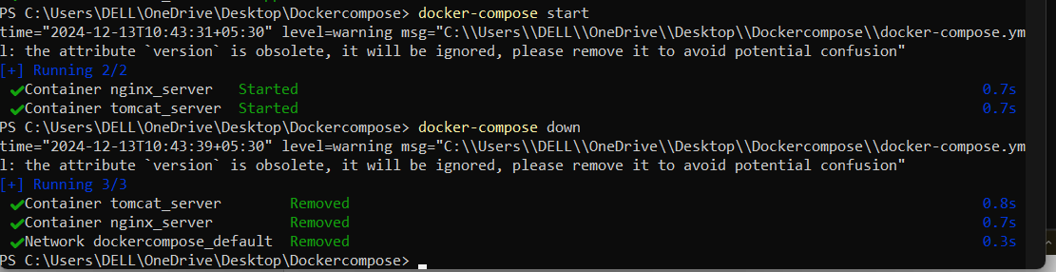

Now start the container and remove it